MA [Creative and Cultural Industries]
School of Arts, Languages and Cultures, University of Manchester
Semester [I]
[SALC60101 Theories and Practices in Creative and Cultural Industries]
Course Convenor: [Leandro Valiati & Priya Sharma]
[Spotify and Inequality:
A Case Study of Innovative Strategies in Creative Business Models]
[11469633]
Date of Submission: 10/01/2024
Word Count: 1988

Spotify and Inequality:
A Case Study of Innovative Strategies in Creative Business Models
Introduction
Business Model Innovation (BMI), as conceptualized by Alexander Osterwalder and Yves Pigneur (2010), is understood as "the rationale of how an organization creates, delivers, and captures value." This concept has undergone significant evolution, particularly within the realm of Creative and Cultural Industries (CCIs), in response to rapid technological advancements. Paolo Landoni et al. (2020) expanded this definition to 'the reconfiguration of the activity system,' highlighting BMI's critical impact on CCIs, ranging from reputation enhancement to bolstering creativity support. Cornelia Dümcke (2015) observed that CCIs are experiencing a paradigm shift in their business models due to these technological evolutions. In the digital era, the influence of BMI on CCIs is profound, offering both challenges and opportunities in shaping contemporary society. Dümcke (2015) emphasizes that the business models within CCIs now encompass broader cultural and social values, reflecting a shift from traditional commercial objectives to more holistic societal impacts.
One of the most significant societal impacts is the emergence of increasing inequalities within CCIs. These disparities, encompassing gender, regional imbalances, and varied levels of individual engagement, have become an ongoing issue of scholarly debate, especially regarding the role of digitalized business models like Spotify in either mitigating or exacerbating these inequalities. This evolving landscape of BMI, juxtaposed with the advent of digital platforms, presents a complex picture of how modern business models in CCIs can both reflect and influence societal norms.
Taking Spotify as a case study, this essay aims to explore the sophisticated dynamics between digitalized business models and the perpetuation of inequalities in CCIs. Spotify, established in Sweden in 2006, has grown to boast 590 million monthly active users and 226 million paying subscribers as of September 2023. Operating in 184 markets, with a substantial footprint in the US and Europe, the platform accounts for 53% of its user base and 67% of its revenue from these regions (Spotify, 2023). This dominance not only underscores Spotify's success but also highlights the financial, cultural, and social disparities that digitalized business models can engender. The central thesis of this essay is that digitalized business models, exemplified by Spotify, reinforce inequality in CCIs, primarily through their distribution processes. This analysis will adopt a structured approach, encompassing an introduction, literature review, discussion, and conclusion, to critically evaluate how Spotify, through its theoretical frameworks, innovative algorithms, and distribution strategies, contributes to the perpetuation of inequality within CCIs.
Literature Review
The discourse on Spotify's influence in the digital music industry encloses a critical dichotomy centred around access and equity. This section aims to dissect Spotify's business models, particularly focusing on the freemium approach and algorithmic personalization, to understand their impacts on equitable distribution within the music industry. This analysis engages with existing scholarly discourses, drawing connections between their findings and the broader implications for equity in digital music distribution.
At the heart of this discourse lies the concept of user engagement. Inês Gomes et al. (2021) celebrate Spotify as a paradigm of innovation in the music industry, praising its freemium model for democratizing music consumption by offering initially cost-free access to a vast library. However, this model subtly nudges users towards a paid subscription, thus creating a separation between free and premium experiences. This observation is further critiqued by Luca Carbone and Jonathan Mijs (2022), who analyse user data and song lyrics to highlight broader societal economic disparities. Their methodology, which involves a critical examination of user interaction data, challenges the perception of Spotify as a meritocratic ecosystem. This critique is deepened by Joseph Dimont (2018), who identifies a "cross-subsidization" within Spotify’s economic model, favouring frequent streamers over sporadic users. The implications of Dimont's findings, based on economic analysis, raise significant questions about the fairness of Spotify's subscription model.
Mansoor Iqbal (2024) contributes to this debate by spotlighting the dichotomy between Spotify’s 220 million subscribers and its 551 million monthly users. The two-tiered experience, segmented by ad interruptions, sheds light on the economic stratification within Spotify's user base. The methodologies employed in these studies, ranging from data analytics to economic modelling, provide a critical insight into the validity and relevance of their conclusions, underscoring the complexities of user engagement within Spotify's business model.
The debate extends to Spotify’s algorithmic framework, an essential aspect of its business model. Joško Lozić et al. (2020) argue that Spotify's algorithms disrupt traditional music distribution's monopolistic nature, leading to a "dematerialization of music archives" that ostensibly empowers user-driven personalization. However, this autonomy is intricately curated by Spotify’s algorithms, which tend to bias recommendations towards certain tracks. This insight is critical in understanding the role of algorithmic curation in reinforcing industry inequalities. Tamas Tofalvy and Júlia Koltai (2023) further assert that these algorithms entrench "core-periphery relations," disproportionately disadvantaging lesser-known artists and those from diverse locations. Dave Laing (2008) corroborates this, pointing to limited consumption of international music in the U.S., suggesting a role for Spotify in fostering cultural bias.
The gender disparity within Spotify’s ecosystem is a crucial aspect of this discourse. Stacy L Smith et al. (2021) highlight the marked underrepresentation of women in popular music, with only 21.6% presence on the Billboard Hot 100 Year-End Charts over nine years. (see Figure 1) This finding reveals a dominance of male-labelled artists across all genres, Ann Werner (2020) critiques Spotify for its role in perpetuating these gender biases, categorizing music along gender lines in its quest to simplify the listening experience.
While Spotify's innovative models have revolutionized access to music, they have concurrently uncovered inequities. The freemium model, despite its accessibility, creates a stark separation between paying and non-paying users. The algorithm-driven personalization, although intended to enhance user experience, may inadvertently entrench biases within the music industry. Therefore, a profound comprehension of Spotify’s role in shaping musical consumption and its consequential impact on distributional equality is imperative. Future research must delve into the socio-economic effects of these models, particularly in emerging markets, to offer a comprehensive understanding of Spotify’s global influence.
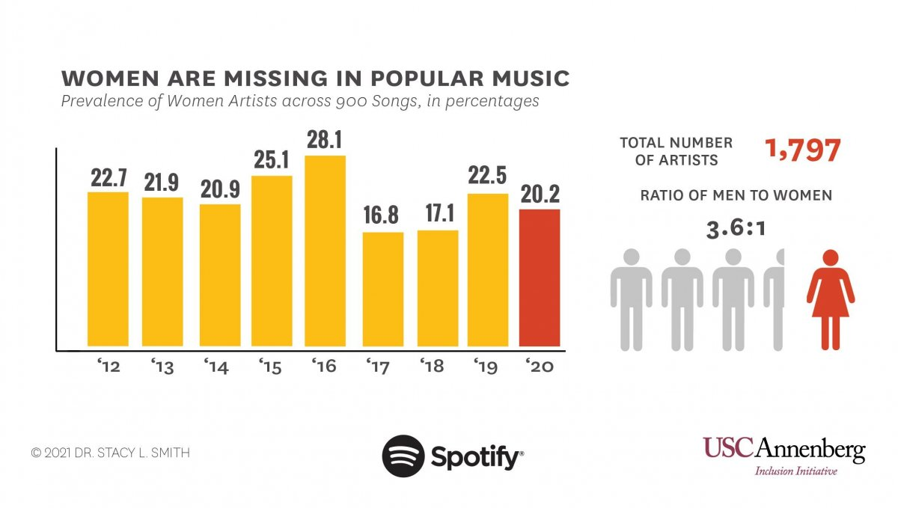
Figure 1 Prevalence of Women Artists across 900 songs in percentages
Discussion
In examining Spotify's influence on reinforcing inequalities within the music industry and the broader creative and cultural industries, a multifaceted analysis is required. This examination must address the disparities across nations, economic revenues, and genders, taking into account the perspectives of musicians, music companies, and users.
National Inequality and Spotify’s Algorithm
Spotify's global influence significantly impacts the music industry, particularly in terms of national representation. Cassidy E. Nelson (2022) highlights the intricate relationship between music tastes and cultural capital, which is influenced by socio-economic factors. Daniel First (2018) critically notes that Spotify's algorithm often favours mainstream, Western music, leading to cultural homogenization. This is further supported by Jonathan Gingerich (2022), who suggests that such algorithms could inadvertently shape global cultural consumption patterns, thus limiting cultural diversity. Pablo Bello and David Garcia (2021) emphasize the prevalence of US-produced music in Spotify's catalogue, contributing to the scarcity of local music in many regions. Compared to other CCIs, Spotify’s algorithmic approach appears to significantly influence cultural representation, potentially leading to a monocultural music landscape.
Inequality among Artists and Revenue Distribution
Spotify's revenue distribution model has significant implications for artists. As Travis M. Andrews (2023) reveals, only 58.5% of Spotify’s revenue is allocated to record labels, posing financial challenges, especially for independent artists. David Hesmondhalgh (2017) further highlights the disproportionate favouring of a small group of popular artists. In contrast, in other CCIs like publishing or film, revenue models often offer more equitable opportunities for independents. Spotify's model, therefore, not only reflects financial inequity but also restricts the diversity of music reaching audiences.
Spotify and the Wider Creative and Cultural Industries
The "spotification" trend, as identified by Fleischer (2021), suggests that various media sectors are emulating Spotify’s business model. However, the success of this model in other CCIs is variable, indicating that it might not be universally applicable. This underscores the need for industry-specific strategies. In comparison, industries like film and literature have developed distinct models that cater to their unique dynamics, suggesting that a one-size-fits-all approach, as seen in Spotify, may not be conducive to the diverse needs of various CCIs.
Gender Inequality in Spotify’s Ecosystem
The gender disparity within Spotify’s platform is another significant concern. As noted by Joel Waldfogel (2018) and Abhishek Nagaraj and Aruna Ranganathan (2022), digital platforms like Spotify may inadvertently exacerbate demographic inequalities. Spotify’s data from 2018 shows only 38.7% female users, 33% female workers, and 31.9% women in leadership positions, indicating a need for more inclusive practices. (see Figure 2) This trend of underrepresentation of women is also evident in other areas of the CCI sector but varies in degree and manifestation.
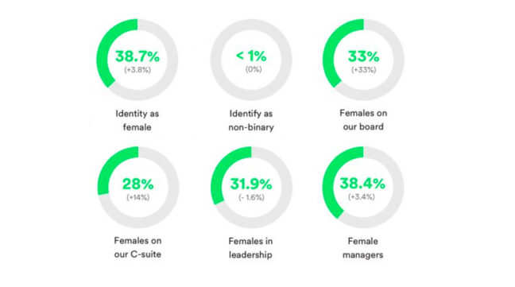
Figure 2 Proportions of Females in Spotify

Looking Forward: Addressing Inequalities in Spotify's Business Model
To address these disparities, Spotify needs to undertake a critical reassessment of its business models. Enhancing the algorithm to promote a broader spectrum of music, including underrepresented artists and genres, is crucial. This might involve developing new metrics that prioritize diversity and inclusivity in content curation. For revenue distribution, exploring more equitable models to support independent artists is necessary. This could include revising payment structures or creating targeted initiatives to nurture emerging talent. Addressing gender inequality requires comprehensive strategies that extend beyond playlist curation. Spotify should aim for gender balance not only in its workforce and leadership but also in its content. Promoting female artists and ensuring equitable representation in playlists and promotional activities is essential. These changes could serve as a model for other CCIs, fostering a more equitable and diverse cultural landscape.
Implementing these solutions, however, presents challenges. Reconfiguring the algorithm to balance user preferences with diversity goals might be technically complex and could impact user experience. Revising revenue distribution models would require negotiations with record labels and artists, potentially disrupting established industry practices. Promoting gender equality entails overcoming entrenched biases and may require significant cultural shifts within the organization. The broader implications of these solutions for the CCI sector are substantial. A more equitable Spotify could set a precedent for other digital platforms, encouraging them to adopt more inclusive practices.
Conclusion
This essay has critically explored the multifaceted ways in which Spotify perpetuates inequalities. Through an extensive analysis of Spotify's algorithmic practices, revenue distribution models, and gender representation, it is evident that the platform's current mechanisms tend to reinforce existing disparities in terms of national representation, artist income, and gender balance.
Spotify’s algorithmic curation, favouring Western, mainstream music, potentially leads to cultural homogenization, as highlighted by Nelson (2022) and First (2018). This phenomenon underscores the need for a more inclusive and diverse representation in the music industry. Moreover, the revenue distribution model, as discussed by Andrews (2023), reveals a financial imbalance that disproportionately affects independent artists. This imbalance in resource allocation contrasts sharply with other CCIs, where more equitable models are often employed. Furthermore, the underrepresentation of women in Spotify’s ecosystem, as noted by Waldfogel (2018) and Nagaraj and Ranganathan (2022), mirrors wider gender disparities in the CCI sector, but also highlights the unique challenges posed by digital platforms.
In conclusion, addressing these inequalities is not only crucial for fostering a more equitable and diverse cultural landscape but also for ensuring the sustainability and relevance of CCIs in a rapidly evolving digital world. Spotify's case provides valuable insights into the challenges and opportunities in this regard, serving as a pivotal example for other digital platforms and CCIs. Future research could delve into developing and implementing more equitable and inclusive business models across various CCIs. This includes exploring new strategies for algorithmic fairness, revenue sharing models that better support diverse artists, and gender-inclusive practices in content and leadership.

Bibliography

Andrews, T. M. (2023, February 4). In the Spotify era, many musicians struggle to make a living - The Washington Post. The Washington Post. https://www.washingtonpost.com/arts-entertainment/2023/02/04/spotify-grammys-songwriters-payment-musicians/

Bello, P., & Garcia, D. (2021). Cultural Divergence in popular music: the increasing diversity of music consumption on Spotify across countries. Humanities and Social Sciences Communications, 8(1). https://doi.org/10.1057/s41599-021-00855-1

Carbone, L., & Mijs, J. (2022). Sounds like meritocracy to my ears: exploring the link between inequality in popular music and personal culture. Information Communication and Society, 25(5), 707–725. https://doi.org/10.1080/1369118X.2021.2020870

Dimont, J. (2018). Royalty inequity: why music streaming services should switch to per-subscriber model. . Hastings Law Journal, 69(2), 675–700.

Dümcke, C. (2015). New Business Models in the Cultural and Creative Sectors (CCSs). European Expert Network On Culture (EENC). www.cultureconcepts.de

First, D. (2018). Will big data algorithms dismantle the foundations of liberalism? AI and Society, 33(4), 545–556. https://doi.org/10.1007/S00146-017-0733-4

Fleischer, R. (2021). Universal Spotification? The shifting meanings of “Spotify” as a model for the media industries. Popular Communication, 19(1), 14–25. https://doi.org/10.1080/15405702.2020.1744607

Gingericht, J., Akar, E., Bialy, F., Boyle, D., Cohn, M., Cooper, D., Dover, D., Furendal, M., Gamez, D., Guo, C., Hughs, M., Keller, P., Kopel, O., Lectherman, T., Lezra, J., Lopes, D. M., Love, S. M., Nguyen, C. T., O’brien, L., … Zucca, L. (2022). Is Spotify Bad for Democracy? Artificial Intelligence, Cultural Democracy, and Law.

Gomes, I., Pereira, I., Soares, I., Antunes, M., & Au-Yong-Oliveira, M. (2021). Keeping the Beat on: A Case Study of Spotify. Advances in Intelligent Systems and Computing, 1366 AISC, 337–352. https://doi.org/10.1007/978-3-030-72651-5_33

Hesmondhalgh, D. (2021). Is music streaming bad for musicians? Problems of evidence and argument. New Media and Society, 23(12), 3593–3615. https://doi.org/10.1177/1461444820953541

Iqbal, M. (2024, January 8). Spotify Revenue and Usage Statistics (2024). Business of Apps. https://www.businessofapps.com/data/spotify-statistics/

Laing, D., & Laing, D. (2009). World Music and the global music industry. Popular Music History, 3(3), 213–231. https://doi.org/10.1558/pomh.v3i3.213

Lozić, J., Vojković, G., & Milković, M. (2020). “Financial” Aspects of Spotify Streaming Model.

Nagaraj, A., & Ranganathan, A. (2022). Singing Your Own Praises: Digital Cultural Production and Gender Inequality.

Nelson, C. E. (2022). The Spotify Buffet: Cultural Omnivorousness and the Democratization of Music Taste.

Osterwalder, A., & Pigneur, Y. (2010). Business Model Generation.

Smith, S. L., Pieper, K., Choueiti, M., Hernandez, K., & Yao, K. (2021). Inclusion in the Recording Studio? Gender and Race/Ethnicity of Artists, Songwriters & Producers across 900 Popular Songs from 2012-2020.

Spotify. (2018, July 9). Say hi to the Spotify diversity data! | HR Blog. https://hrblog.spotify.com/2018/07/09/say-hi-to-the-spotify-diversity-data/

Spotify. (2023). Q3 2023 Update.

Tofalvy, T., & Koltai, J. (2023). “Splendid Isolation”: The reproduction of music industry inequalities in Spotify’s recommendation system. New Media and Society, 25(7), 1580–1604. https://doi.org/10.1177/14614448211022161

Waldfogel, J. (2018). Digital Renaissance. Princeton University Press.

Werner, A. (2020). Organizing music, organizing gender: algorithmic culture and Spotify recommendations. Popular Communication, 18(1), 78–90. https://doi.org/10.1080/15405702.2020.1715980

